الاسم/ .................................................... الصف/ ...............................................

( B ) U2 & U3

Top Goal2اختبار الفترة الثانية للفصل الدراسي الأول
- match
B | A
( ) a scientist  ( ) driver.  ( ) An architect  ( ) journalist | a- Someone who reports the news.  b- Who designs houses?  c- You can see this person on bus or car.  d- A person trained in science is called
2- Choose the correct answer:
1. I will ( look - looking - looks ) for the Wi-Fi!
2. Are ( he - we - I ) going to watcha movie?
3. He is going to work here, ( is he - he is - isn't he ) ?
4. I am not going ( to sleep - sleep to - sleep ) at home tonight.
3- Rearrange this sentence
going to / a book / I am / read/ . ………………………………………………………………………………………………………
4- Match :
tower - engineer - factory - racoon can
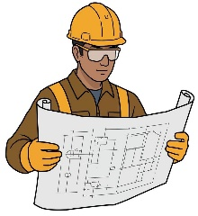
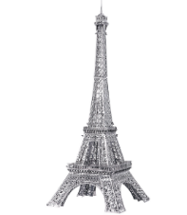



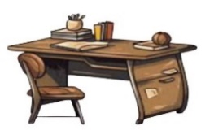
5- Fill in the missing letters: ( p - n - i - f )

of _ ice scree _ pil _ t

